ESP32: K-Type Thermocouple with MAX6675 Amplifier
In this guide, you’ll learn how to read temperature using a K-Type Thermocouple with the MAX6675 amplifier with the ESP32 board. A K-type thermocouple is a type of temperature sensor with a wide measurement range like −200 to 1260ºC (−326 to 2300ºF).

What is a K-Type Thermocouple?
A thermocouple is a device that consists of two different electrical conductors that form an electrical junction—thermal junction. The change in temperature at the junction creates a slightly but measurable voltage at the reference junction that can be used to calculate the temperature.
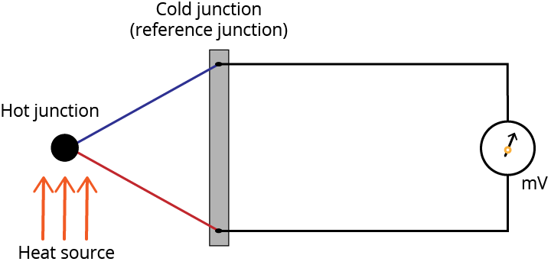
A thermocouple can be made of different metals. The metals used will affect the voltage range, cost, and sensitivity. There are standardized metal combinations that result in different thermocouple types: B, E, J, N, K, R, T, and S.
Our tutorial is about the k-type thermocouple. A k-type thermocouple is made out of chrome and alumel conductors and has a general temperature range of −200 to 1260ºC (−328 to 2300ºF).
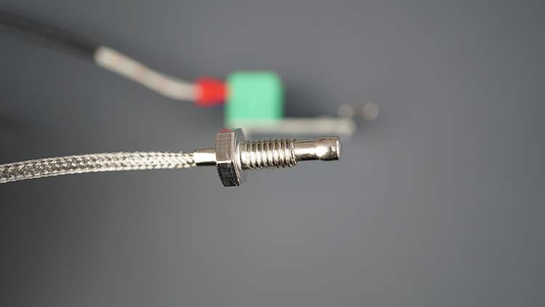

MAX6675 Amplifier
To get the temperature from the thermocouple we need a thermocouple amplifier. The temperature output from the thermocouple amplifier depends on the voltage read on the reference junction. The voltage at the reference junction depends on the temperature difference between the reference junction and the thermal junction. So, we need to know the temperature at the reference junction.
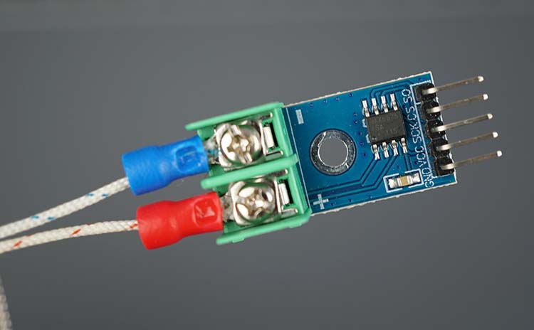
The MAX6675 thermocouple comes with a temperature sensor to measure temperature at the reference junction (cold-compensation reference) and amplifies the tiny voltage at the reference junction so that we can read it using our microcontrollers. The MAX6675 amplifier communicates with a microcontroller using SPI communication protocol and the data is output in a 12-bit resolution.
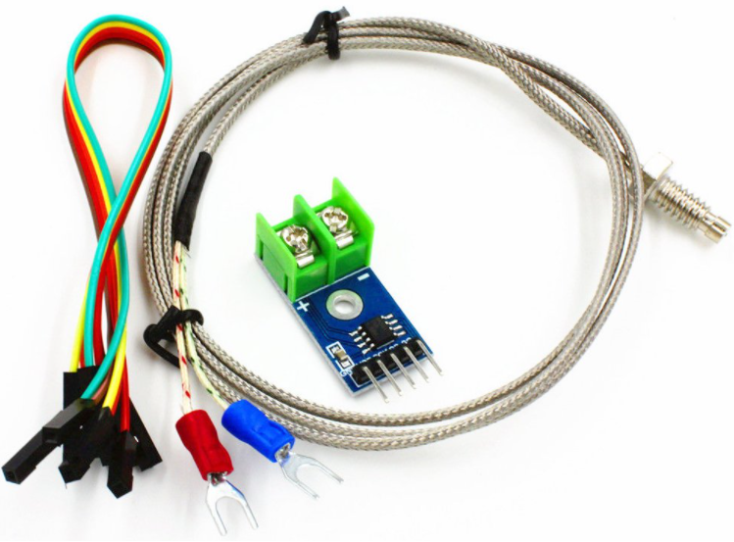
Usually, you can get a pack with a k-type thermocouple and the MAX6675 amplifier. Here’s a list of the MAX6675 most relevant features. For a more detailed description, please consult the MAX6675 datasheet.
- Direct digital conversion of type -K thermocouple output
- Cold-junction compensaiton
- Simple SPI-compatible serial interface
- Operating voltage range: 3.0 to 5.5V
- Operating temperature range: −20 to 85ºC
- Resolves temperatures to 0.25ºC, allows readings as high as 1024ºC (1875ºF).

Interfacing K-Type Thermocouple with MAX6675 Amplifier
As mentioned previously, the MAX 6675 communicates with a microcontroller using SPI communication protocol.
MAX6675 | Microcontroller
SO | MISO
CS | CS
SCK | CLK
VCC | VCC (3.3V or 5V)
GND | GND

Get Temperature from K-Type Thermocouple with MAX6675 Amplifier
In this section, you’ll learn how to get temperature from your k-type thermocouple. We’ll show you a simple example that reads the temperature and displays it on the Arduino IDE Serial Monitor.
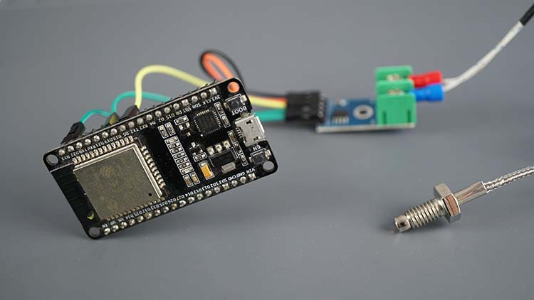

Parts Required
To complete this tutorial, you need the following parts:
- K-type thermocouple with MAX6675 amplifier
- ESP32 (read Best ESP32 development boards)
- Jumper wires (female-to-female)
You can use the preceding links or go directly to MakerAdvisor.com/tools to find all the parts for your projects at the best price!

Schematic – ESP32 with K-type thermocouple and MAX6675 Amplifier
Wire the MAX6675 Amplifier to the ESP32 as shown in the following schematic diagram.
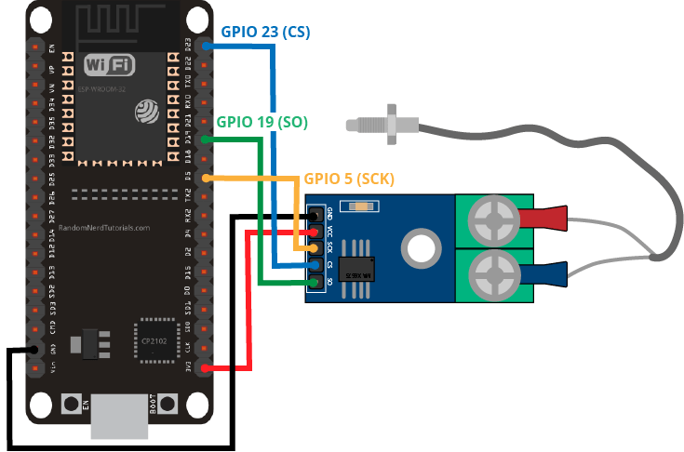
You can also follow the next table.
MAX6675 | ESP32
GND | GND
VCC | 3.3V
SCK | GPIO 5
CS | GPIO 23
SO | GPIO 19

Installing MAX6675 Arduino Library
There are different libraries to get temperature from a K-type thermocouple using the MAX6675 amplifier. We’ll use the max6675 library from Adafruit.
Follow the next steps to install the library in your Arduino IDE:
Open your Arduino IDE and go to Sketch > Include Library > Manage Libraries. The Library Manager should open.
Search for “max6675 ” in the search box and install the library from Adafruit.
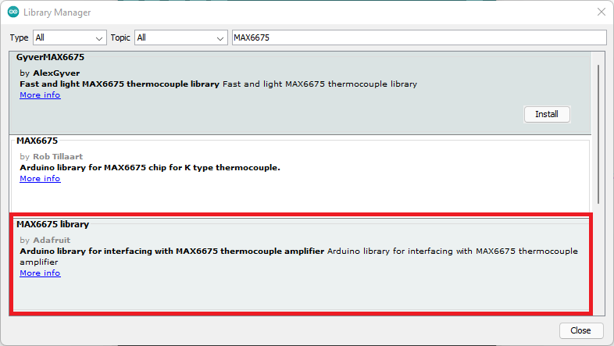

Code – Get Temperature from K-Type Thermocouple with MAX 6675 Amplifier
Getting temperature from the K-Type thermocouple with the ESP32 is very simple. The library provides an example that gets temperature and displays the results on the Arduino IDE Serial monitor.
The code was adapted from the example provided by the library to make it compatible with the ESP32.

How the Code Works
First, include the max6675.h library.
#include "max6675.h"
Define the pins that are interfacing with the MAX6675 thermocouple amplifier.
int thermoDO = 19;
int thermoCS = 23;
int thermoCLK = 5;
Create a MAX6675 object called thermocouple on the pins we’ve defined previously.
MAX6675 thermocouple(thermoCLK, thermoCS, thermoDO);
In the setup(), initialize the Serial Monitor at a baud rate of 9600.
Serial.begin(9600);
In the loop(), we read the temperature and display it on the Serial Monitor. The library provides a method to read the temperature in Celsius and a method to read the temperature in Fahrenheit degrees.
- thermocouple.readCelsius(): returns temperature in Celsius degrees.
- thermocouple.readFahrenheit(): returns temperature in Fahrenheit degrees.
The following lines read the temperature and display it on the Serial Monitor.
Serial.print("C = ");
Serial.println(thermocouple.readCelsius());
Serial.print("F = ");
Serial.println(thermocouple.readFahrenheit());
As you can see, it’s very simple to get temperature readings using the K-type thermocouple with the MAX6675 amplifier.

Demonstration
Upload the code to your ESP32 board. Don’t forget the select the board you’re using in Tools > Board and select the COM port your board is connected to in Tools > Port.
After uploading the code to the ESP32, open the Serial Monitor at a baud rate of 9600. Press the ESP32 on-board RST button.
New temperature readings are displayed on the Serial Monitor every second.
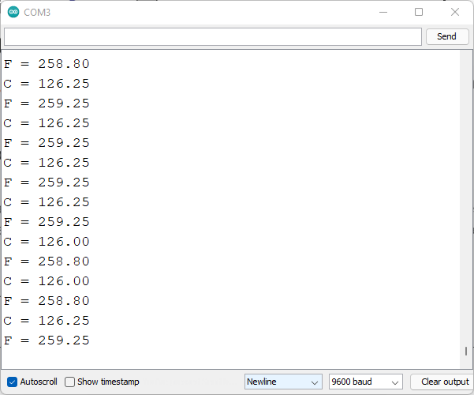

Wrapping Up
In this tutorial, you learned how to read temperature using the k-type thermocouple with the MAX6675 amplifier. Thermocouples have a wide temperature measurement range and allow you to read very high temperatures—as high as 1024ºC (1875ºF) when using k-type thermocouple with MAX6675.
We have tutorials for other popular sensors with the ESP32 board that you may like:
- ESP32 with DS18B20: Temperature Sensor
- ESP32 with BME680: Gas, Pressure, Humidity, and Temperature Sensor
- ESP32 with BME280: Temperature, Humidity, and Pressure Sensor
- ESP32 DHT11/DHT22: Temperature, and Humidity Sensor
- ESP32 with BMP388: Altimeter Sensor
- ESP32 HC-SR04: Ultrasonic Distance Sensor
- ESP32 PIR: Motion Sensor
- ESP32 BMP180: Pressure Sensor
- ESP32 with BH1750 Ambient Light Sensor
Learn more about the ESP32 with our resources:
- Learn ESP32 with Arduino IDE (eBook + video course)
- Build Web Servers with ESP32 and ESP8266 eBook
- More ESP32 tutorials and projects…

// this example is public domain. enjoy! https://learn.adafruit.com/thermocouple/

#include "max6675.h"

int thermoDO = 19;
int thermoCS = 23;
int thermoCLK = 5;

MAX6675 thermocouple(thermoCLK, thermoCS, thermoDO);

void setup() {
Serial.begin(9600);

Serial.println("MAX6675 test");
// wait for MAX chip to stabilize
delay(500);
}

void loop() {
// basic readout test, just print the current temp

Serial.print("C = ");
Serial.println(thermocouple.readCelsius());
Serial.print("F = ");
Serial.println(thermocouple.readFahrenheit());

// For the MAX6675 to update, you must delay AT LEAST 250ms between reads!
delay(1000);
}

